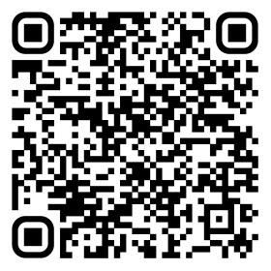  WIFI PASSWORD | WIFI PASSWORD | WIFI PASSWORD

FREE WIFI | FREE WIFI | FREE WIFI

